# *TXT TO CSV* Data Processor Manual -v5

### What’s new in v5

* Update the support for “WMEGEN2-1” & “WMEGEN2-2”

### What’s new in v4

* Support a new type “WMT”
* Update the support for type “WMEGEN2”

### What’s new in v3

* Fixed conversion false for WTC format.
* Add time stamp in Multiple conversion output file names:

As shown below:

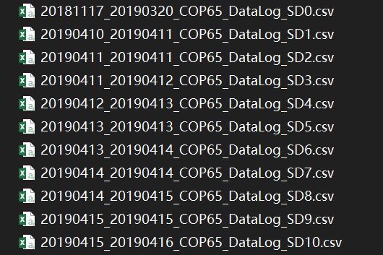

### What’s new in v2

* Added the Multiple file Convert function, which allows users to easily convert several files.

# Usages

## Single File Conversion

1 Choose **Device types** at right up corner. (WXEs separated in 1-4)

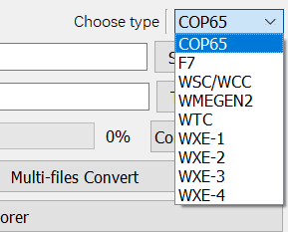

2 Type in the directory of source .txt file and target .csv file.

2' Or you could hit **Browser** to load the file directory. The file name will be shown in the box.

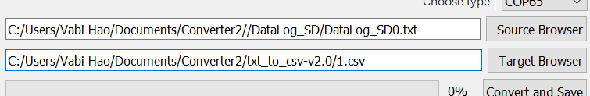

3 Click on **Convert and Save**.

4 No information would show unless something's wrong.

## Multiple Files Conversion

1. Choose **Device types** at right up corner. (WXEs separated in 1-4)

2. Hit **Set Save Directory** to set the folder where you want to save the output files. The location you chose will be shown in the box above.

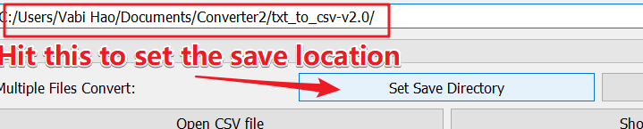

3. Hit **Multi-files Convert** to choose files and the program will start the conversion.

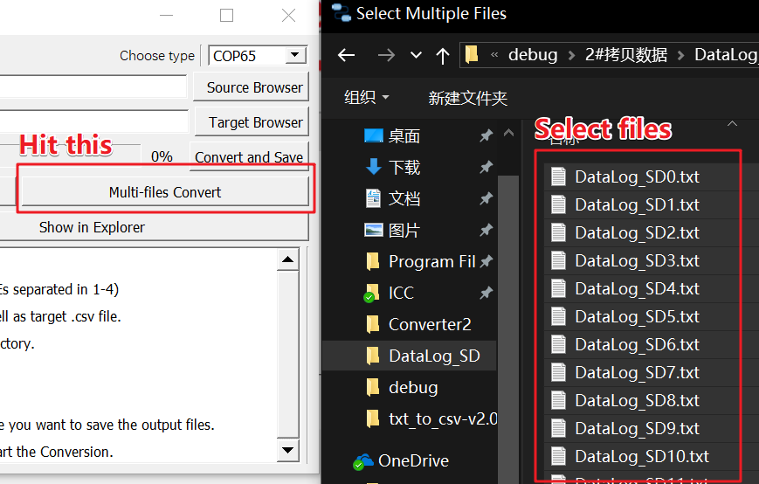

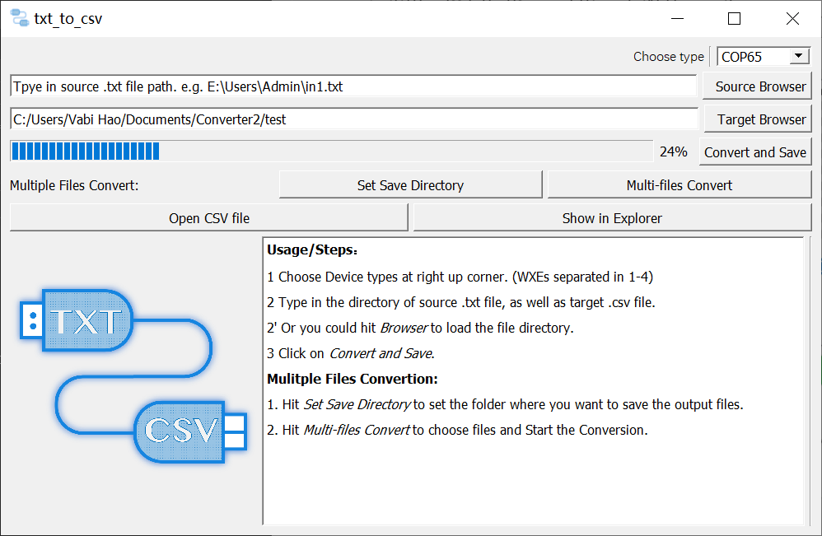

4. Note that the files will be named as ~~*type*_*original name*, e.g. COP65_DataLog_SD0.csv~~ *begin time*_*end time*_*type*_*original name*, as shown below.

